Learning To Sail
CLASS #2
WIND AND HOW TO USE IT

WIND - The most important thing in sailing
- Where is it coming from?
- The waves often run perpendicular to the wind direction.
- How does it feel on your face and arms?
- How strong is it?
Knots - Term used to show wind strength (1 knot = 1.15 mph)
Puff - Means an increase in wind strength. Generally the water is darker in color in a puff.
Lull - Means a decrease in wind strength. Generally the water is lighter in color than the surrounding area.
- Determining the status of the boat
- Which Tack? This is defined by which side of the boat the boom is on. If the boom is on the port side of the boat, you are on a starboard tack. If the boom is on the starboard side of the boat, you are on a port tack. You can also think of it as being the same as the side of the boat that the wind first hits.
- What point of sail?

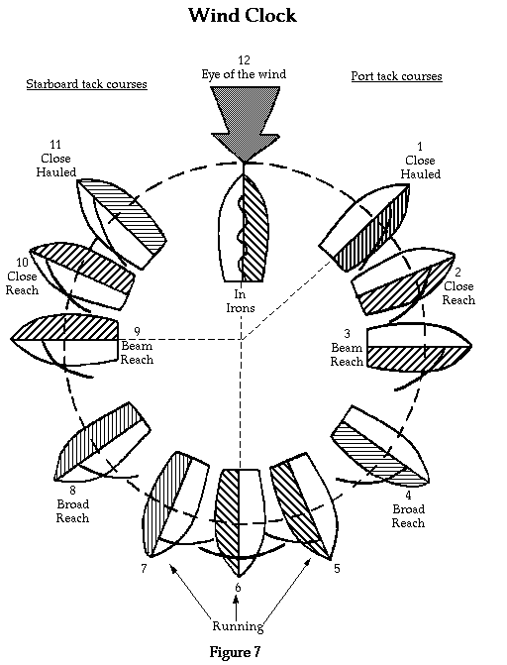

III. SKIPPER POSITION AND STEERING
- Where do you sit?
The skipper usually sits on the windward side of the boat. Why?
- This generally allows greater visibility.
- It generally balances the boat better in the wind.
The crew sits wherever they are needed in order to properly balance the boat or trim sails.
- How do you steer?
- When moving forward the skipper pushes the tiller away from the direction you want to go. If you want to turn to the left, push the tiller to the right.
- When moving backward, push the tiller in the direction you want to go.
- Heading up/Falling off.
- To “head up” means to turn the boat towards the wind.
- To “fall off” means to turn the boat away from the wind.
IV. TACKING AND JIBING
- Tacking
Turning the BOW of the boat through the wind.
If done repeatedly in order to go to windward, sometimes called “beating.”
Steps involved in tacking:
- Warn your crew - “Prepare to tack!”, “Ready about!”
- Wait for crew preparation - “Ready!”
- Announce Tack - “Tacking!”, “Helm’s a’lee!”, “Helm’s over.”
- Steer through the tack (4-6 are generally done simultaneously).
- Tack the jib.
- Shift weight to the new positions.
- Set the new course and trim and adjust sails.
- Jibing
Turning the STERN of the boat through the wind.
Because of the great movement of the boom, it can be dangerous.
Steps involved in jibing:
- Warn your crew - “Prepare to jibe!”
- Wait for crew preparation - “Ready!”
- Announce jibe - “Jibing!”, “Jibe Ho!”
- Steer slowly through the jibe (4-6 are generally done simultaneously).
- Bring mainsheet in, pull boom over center by hand, and release to the other side.
- Shift crew to new positions.
- Set new course and trim and adjust sails.

V. SAIL TRIM
  - SHEETING
- “Sheeting out” means letting your sail out away from the centerline of the boat.
- “Sheeting out” is also called “easing the sheets”, or “easing out the sails.”
- “Sheeting in” means pulling your sail in toward the centerline of the boat.
  - SAILING THEORY
- When sailing upwind, the wind flow over the sails creates lift that “pulls” the boat forward and sideways.
- The sail works much like an airplane wing generating lift and power.
- The keel or centerboard counteracts the sideways force from the sail and allows the boat to move forward.
- When sailing downwind, the wind flow over the sails “pushes” the boat forward
- The sails in this case act like a big parachute
- This is called the “push-pull” principle
- SAIL POSITION
- Sailing upwind, the sails should be in tight, near the centerline of the boat.
- Sailing downwind, the sails should be out away from the centerline of the boat.
- For other points of sail refer to pages in the book.
- TELLTALES
- Telltales “tell the tale” of what the wind is doing around the sails.
- If airflow is even or smooth, they stream back.
- If airflow is turbulent or rough, they flutter all around indicating poor trim on sails.
- Telltales on the sails generally only work upwind, not downwind!
- If inside (windward) telltale flutters, sheet in or fall off.
- If outside (leeward) telltale flutters, sheet out or head up.
- SAIL TRIM BASED ON WIND SPEED
- In light air (light winds), sails should be fat to collect all the wind they can.
- Fat sails are “powered up” and generate greater initial power.
- Sails can be “powered up” by easing out the outhaul, cunningham, and halyard.
- In heavy air (strong winds), sails should be flat and tight.
- Flat sails are “depowered” and generate less power and less heel.
- Sails can be “depowered” or flattened by tightening up the outhaul, cunningham, and halyard.

